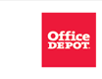

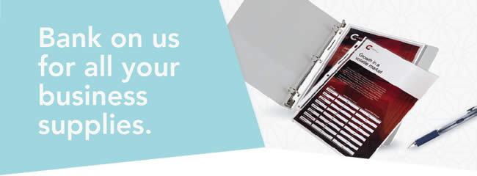
One great partnership.  So many discounts!  Office Depot® is a proud partner of your state bankers association. As a member, you get exclusive discounts on a huge selection of business supplies, cleaning & breakroom products, furniture and more:  • UP TO 80% OFF prices on a core list of 840+ frequently ordered products  • COMPETITIVELY PRICED DISCOUNTS on your own customized list of 75 items  • UP TO 10% OFF the everyday regular prices at officedepot.com on select products in our full-line catalog  • FAST & FREE DELIVERY on qualifying orders of $50 or more within our local delivery areas. See below for details.  • DISCOUNT PROGRAM for your employees | 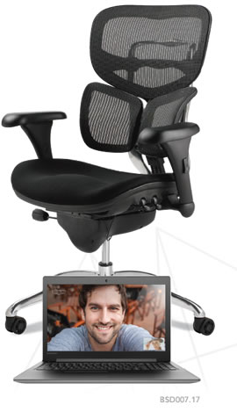

Register for your Office Depot® account today at
business.officedepot.com/banksignup
or place your order today at business.officedepot.com

Office Depot is a trademark of The Office Club, Inc. © 2017 Office Depot, Inc. All rights reserved.
Fast & FREE Delivery: Minimum purchase required after discounts and before taxes. Orders outside our local delivery area and most furniture, oversized and special order items do not qualify. Nonqualifying orders incur a delivery charge (minimum charge of $7.95). Many orders can be delivered next business day (between 8:30 AM and 5:00 PM) if placed online or via phone by 5:00 PM or via fax by 3:00 PM, local time (In most locations) .Other restrictions apply. See business.officedepot.com, call 888.2.OFFICE or ask your Account Manager for details.
Valid at business.officedepot.com or by phone at 888.2.OFFICE and fax at 888.813.7272 only. Offers are non-transferable. Office Depot reserves the right to limit quantities sold to each customer. We are not responsible for errors.

