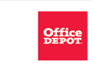 | 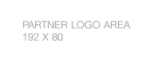

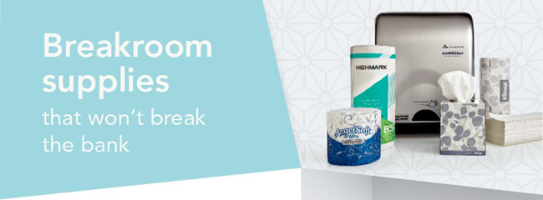
As a member of your state bankers association, you receive exclusive discounts at Office Depot® on breakroom necessities, as well as other office supplies that keep your business running smoothly.  From snacks and beverages to paper products and cleaning solutions, we have the items you need. Plus, we’ll deliver your supplies when and where you need them.  Did you know our exclusive brand of quality-tested Highmark® paper products and Executive Suite® coffees are designed to meet or beat the quality of national brands. And check out the great low price. Stock up today. | 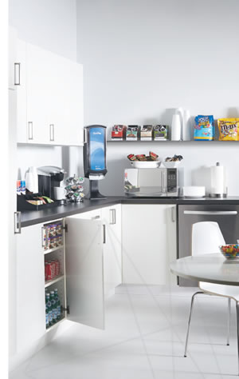

 | 
  Register for your Office Depot® account at
  business.officedepot.com/banksignup
  or place your order today at business.officedepot.com

Office Depot is a trademark of The Office Club, Inc. © 2017 Office Depot, Inc. All rights reserved.

