 | 


April is Stress Awareness Month, which means it’s the perfect time to reduce the stress in your work life. From breakroom essentials and desktop accessories to cleaning supplies and office furniture, Office Depot® has what you need to improve your workspace well-being.
To get started, follow these 5 simple tips:
  TIP #1
  Drink plenty of water.
  Stock up on bottles to use at your desk or for meetings. Or make frequent trips to your office’s water dispenser. Crisp, cold water gives you a boost during the day.
  TIP #3
  Declutter and organize.
  Get rid of items that serve no purpose and file away paperwork that you don’t need right away. Use a calendar or planner to keep you on track.
  TIP #5
  Sit comfortably.
  Don’t let your desk job take a toll on your body. Choose an ergonomic chair that offers lumbar support to improve posture and reduce leg tension.
  As a member of your state bankers association, you receive exclusive discounts on Office Depot supplies that keep both you and your office running smoothly.
  TIP #2
  Don’t eat alone.
  No need to eat at your desk. Socialize with colleagues in your breakroom. A well-stocked, clean breakroom lends to happy dining.
  TIP #4
  Clean your workspace.
  After your space is organized, clean your workspace just like you would your home. You do spend most of your day there!
  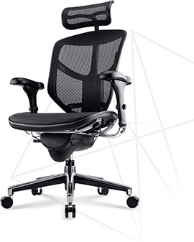


 | 
  Register for your Office Depot® account at
  business.officedepot.com/banksignup
  or place your order today at business.officedepot.com

Office Depot is a trademark of The Office Club, Inc. © 2017 Office Depot, Inc. All rights reserved. BSD050.17

